Connecting to remote network with AWS Site-to-site VPN

A. Network design with multiple VPCs

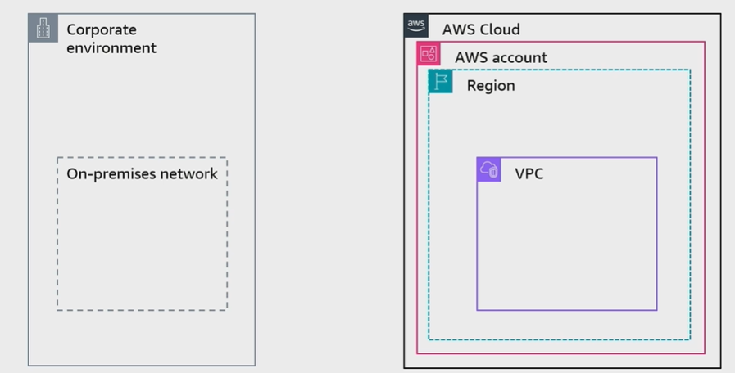
B. AWS Site-to-site VPN
- Creates a secure connection between an on-premises customer gateway and AWS virtual private gateway (or transit gateway) for VPC access
- Creates two encrypted IPsec VPN tunnles for each connection across multiple AZs
- Charges for each VPN connection-hour

C. Connecting multiple on-premises networks by using AWSCloudHub
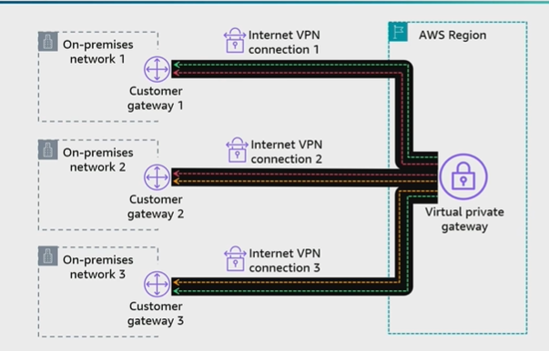

D. Accelerating Site-to-site VPN connections
